6TH - 8TH GRADE

TUESDAYS

2:45PM - 3:45PM

2/14 - 5/23
SKIP: 4/4

WILLIAMSBURG MIDDLE SCHOOL CHESS CLUB
Fun is the name of the game...
...but Magnus Chess Academy also sneaks in a bit of critical thinking, sportsmanship, and patience into chess club!
Each week students of all levels do a fun but challenging lesson with one of our great coaches from our world class curriculum followed by practice games against other students in the class.
Join the 100,000 (and counting!) kids who've learned chess with the official academy of world champion Magnus Carlsen. This in-person club includes online extras like practice tournaments and a bonus lesson with Magnus or Judit Polgar, the best female chess player ever!

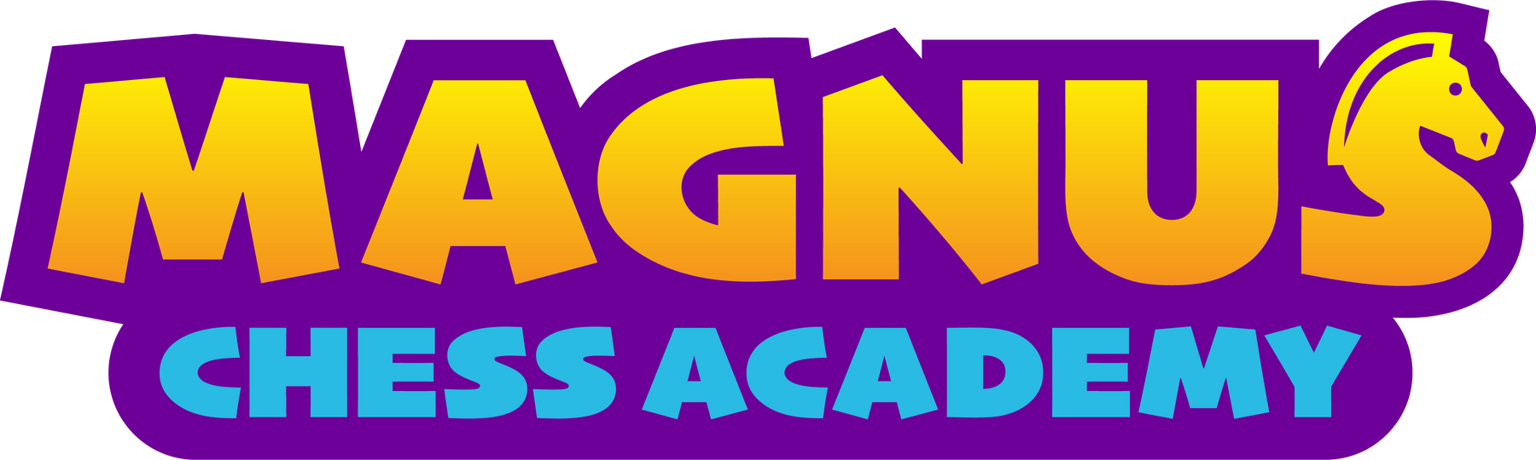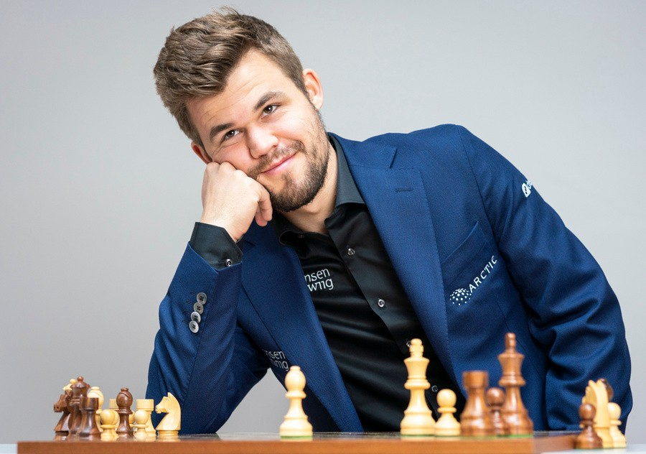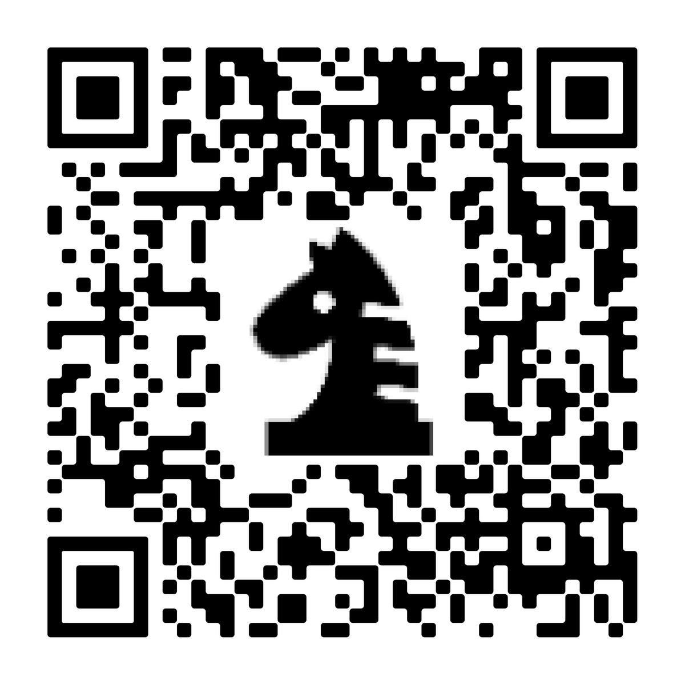
No club meeting on school closure or early dismissal days

TUITION: $252 FOR 14 WEEKS

To register, scan the QR Code
or visit
www.chessacademy.com
to find out more including financial aid information

Questions? Email: info@chessacademy.com or call: 703.574.2070

