Some Tips That May Help with Home Wi-Fi Connection

Before you connect to your home Wi-Fi network, try turning off the VPN first. If you have already connected to home Wi-Fi before, you may want to forget the network before you try the following steps:

- Find the VPN Button in Settings and Turn it Off
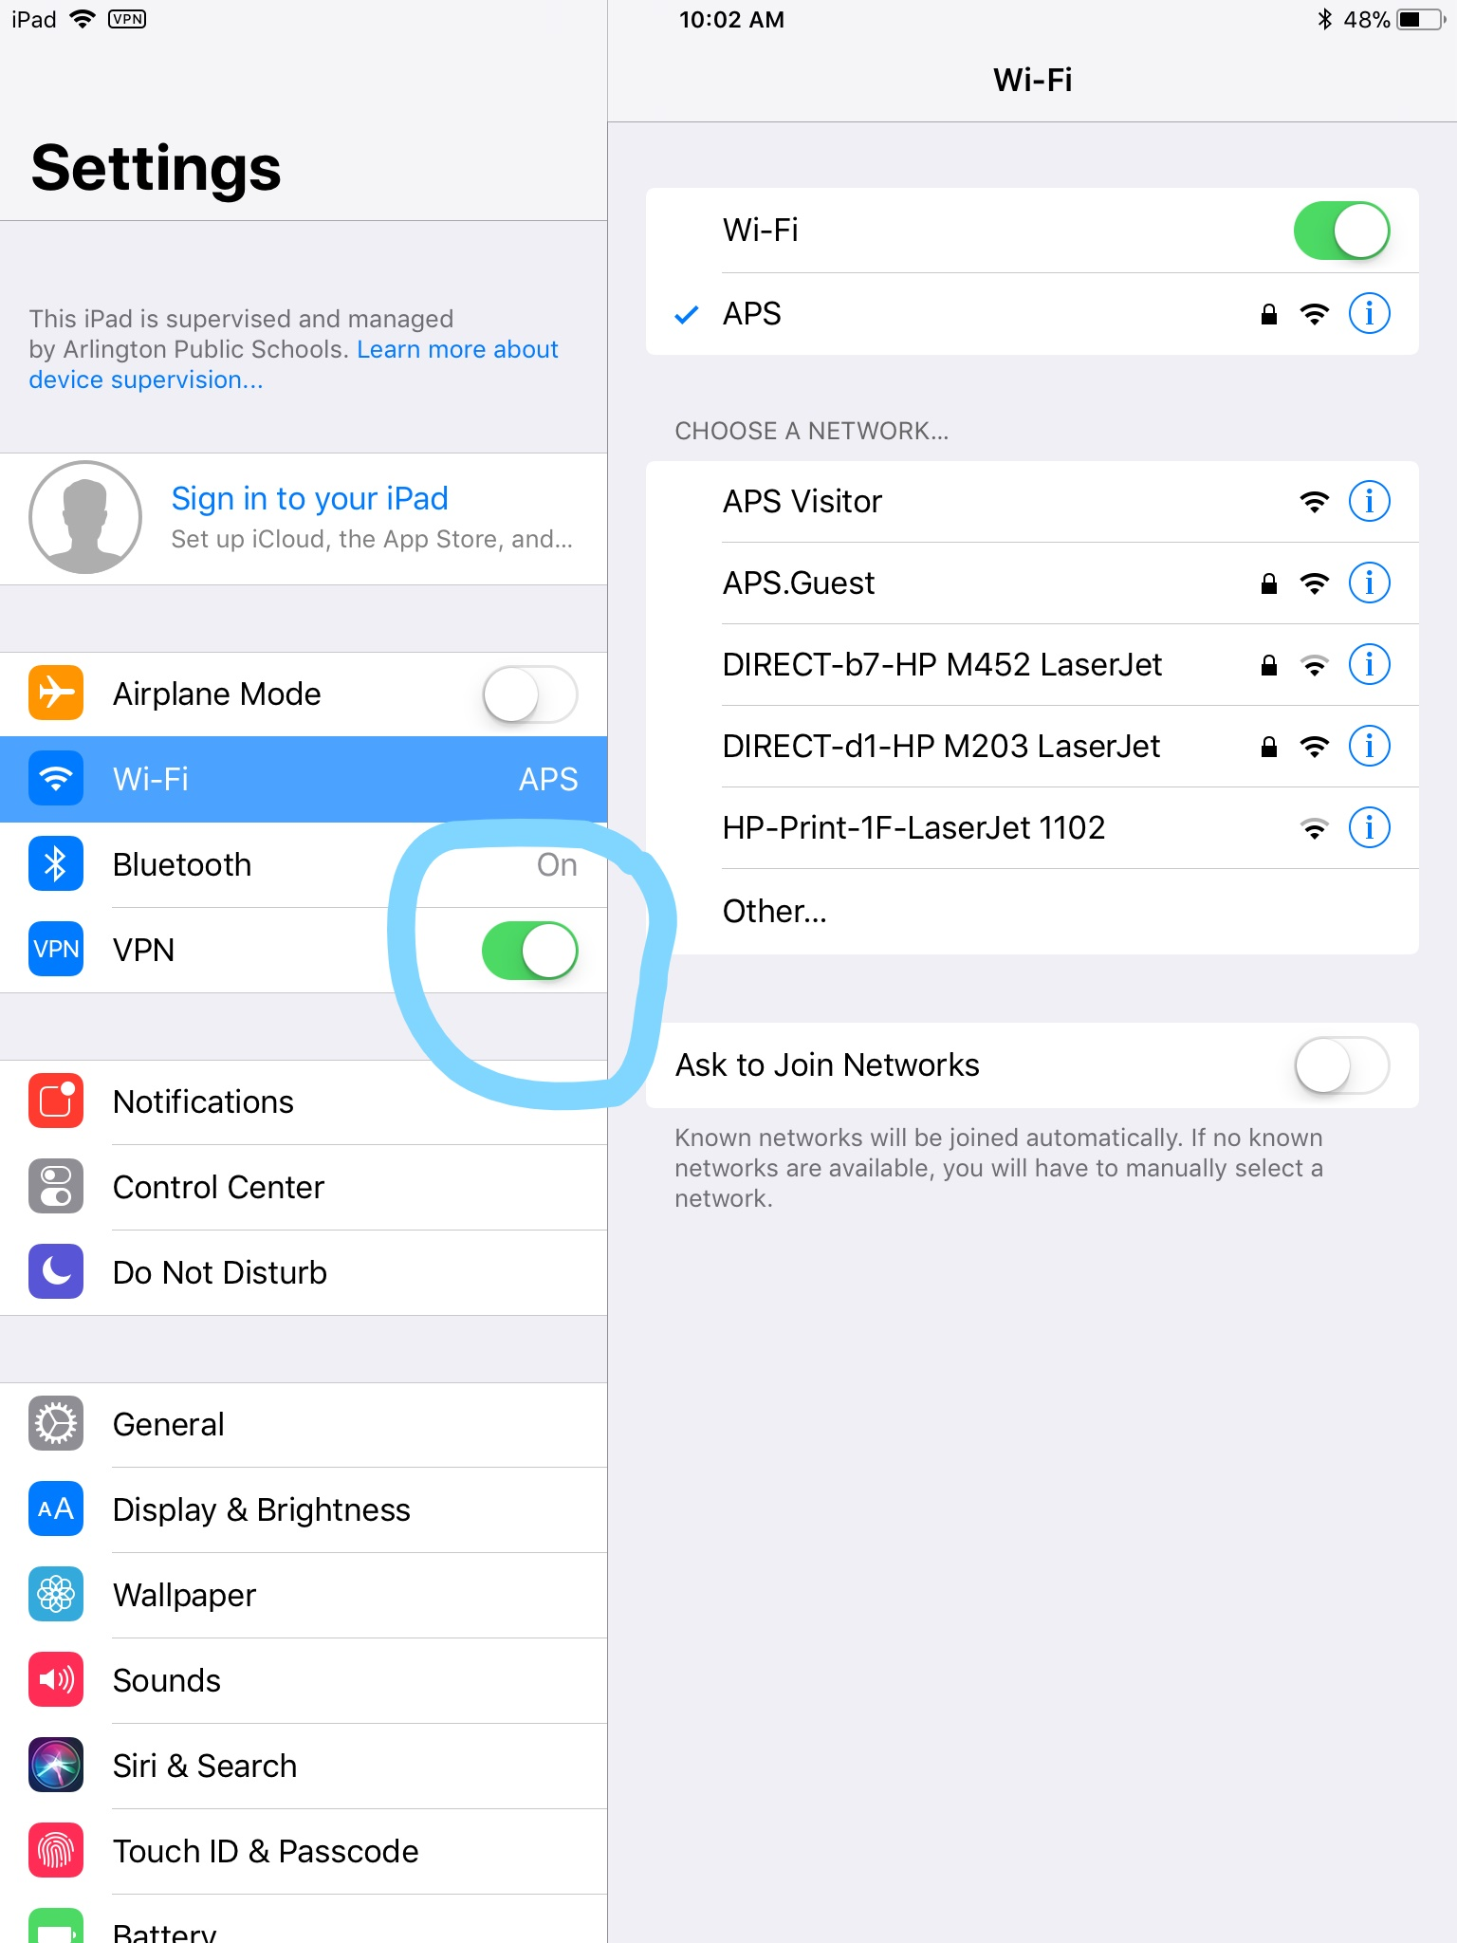
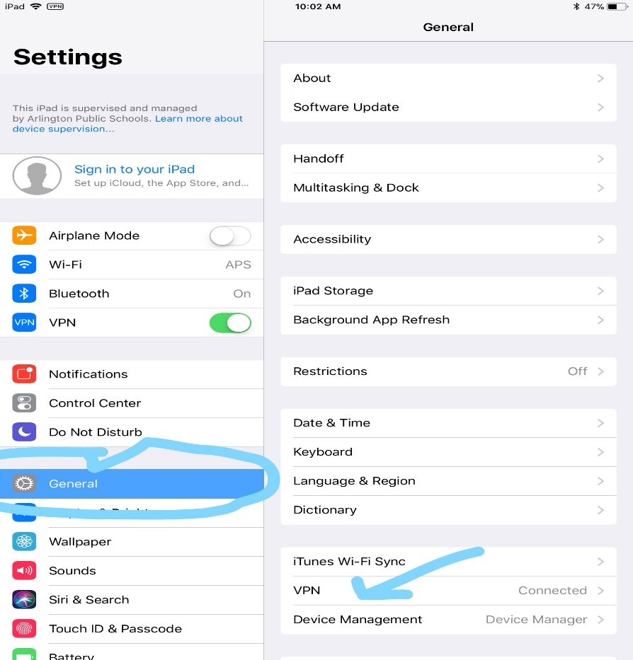
- Click on General in Settings and then Click on VPN on the right side.
- Click on the Blue I next to APS Global Protect.
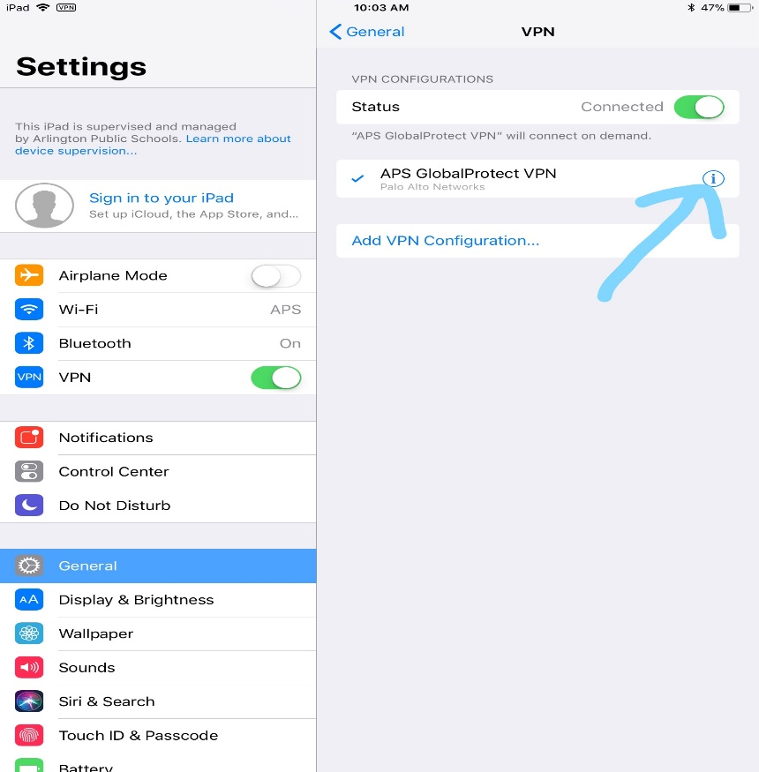

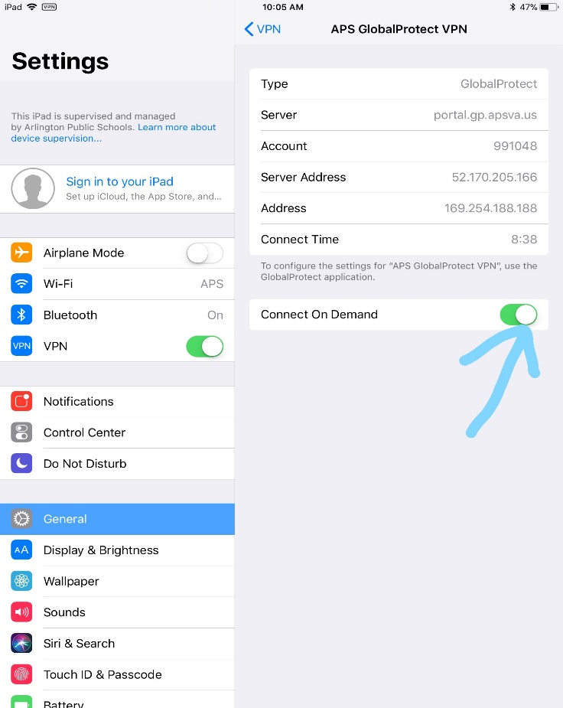
- Turn off Connect on Demand.
- After turning off the VPN in these places, try connecting to your home Wi-Fi. If you are successful in connecting, reverse the previous steps to turn the VPN back on.

